1. Feasibility Study
   1. Economic Feasibility
      1. Developmental cost

* Regardless of getting information . the project is targeted on the artist and their surroundings, As artist are very hard to find Their will be a lot of work done to get to them in the first place so in the process there will be a lot of money spent in the process. Because of this and other reason we will describe later their will not be many interviews or …
* Because of all the developers are the owner of the app during the development phase there is no pavement for the developers.
  + 1. Operational Cost
* Server rental and set up cost
* Advertisement cost
  1. Technical Feasibility
* The technical aspect of the system have less cost and easily accessible we can say for free. The only problem is the user should have smart phone to use the system and internet availability which is the core part of our scope.
* using online transaction that is provided by CBE or hello cash the transaction can be held
  1. Schedule Feasibility
* No idea for now…

## **Project Management plan**

## **Time Management plan**

Figure 1

Describe the entire project schedule using gant chart and additional tabular description if necessary

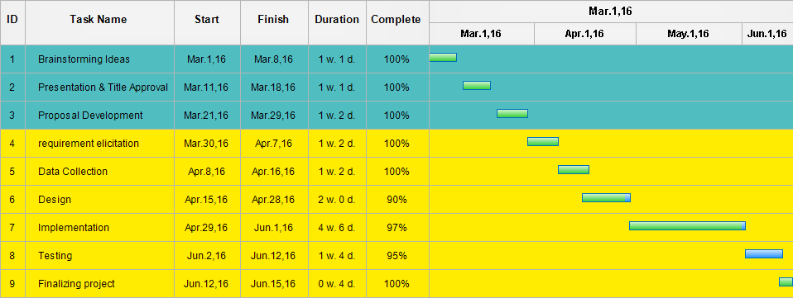

1. **Quality Management Plan**

*[Describe the potential risks related to the software quality. Provide the project management plan to enable quality. Describe the salient, planned testing considerations.]*

*[OPTIONAL CONTENT: Include any analysis plan for usability and acceptance testing.]*

1. **Communication Management Plan**

*State the principles for reporting and distributing information within the project for the different groups of internal and external stakeholders. Include, for example, how often the reporting will take place, the type of reports or information, the type of media in which it is presented, and the type of meetings that will take place.*

*Internal communication and reporting: ensure that all information is available to those who need it.  
– Plan project meetings, how often they take place, and who will participate*